**Valeriu Bologa Library**

Pre-registration

In order to access all the information made available on-line by the Valeriu Bologa library, as well as to keep updated on all our services and other announcements, we advise you to access the institutional site of the University of Medicine and Pharmacy, “Iuliu Haţieganu”, Cluj-Napoca at <http://www.umfcluj.ro/educatie-ro/reurseedu-ro/biblioteca-ro>

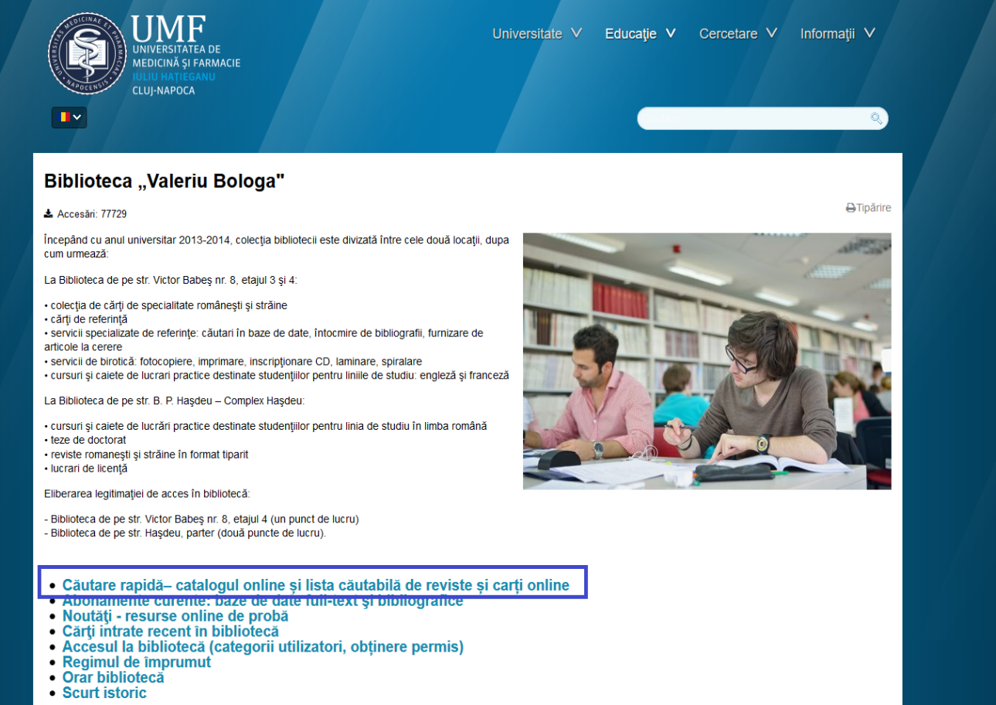

Click **Quick search – Online catalog** and you will be redirected to the **Online catalog (OPAC)** interface.

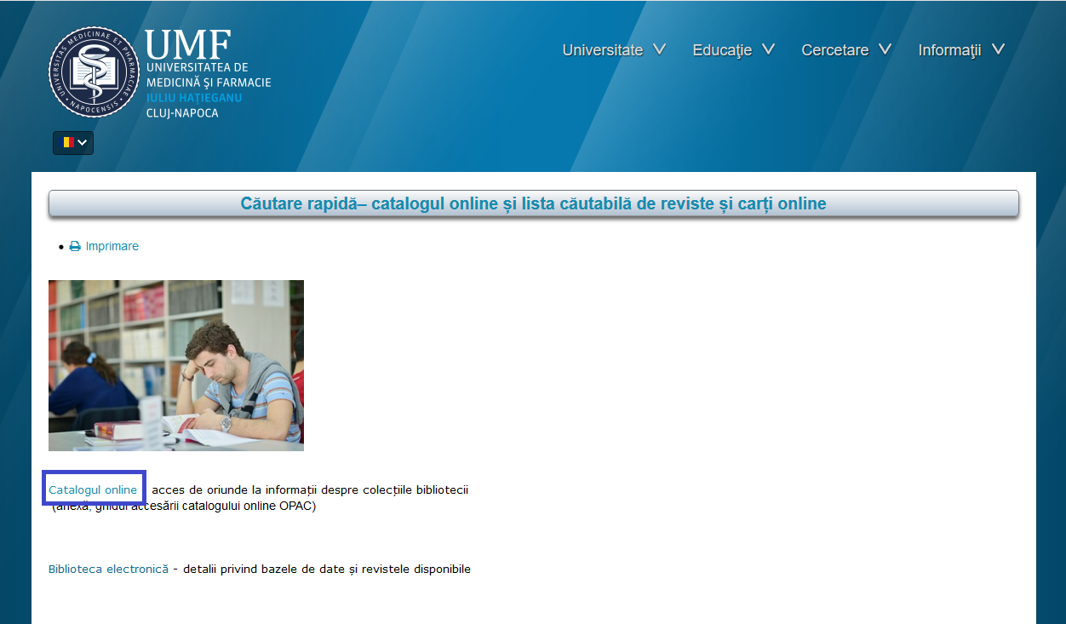

* Q: I want to register. What do I do?

A: The **Online** **Catalog** allows you to consult the list of resources available in the library from any location as long as you have an internet connection. It also allows you to register as a new user and log in in order to check your own user’s file, to view and/or renew your loans and to make a reservation.

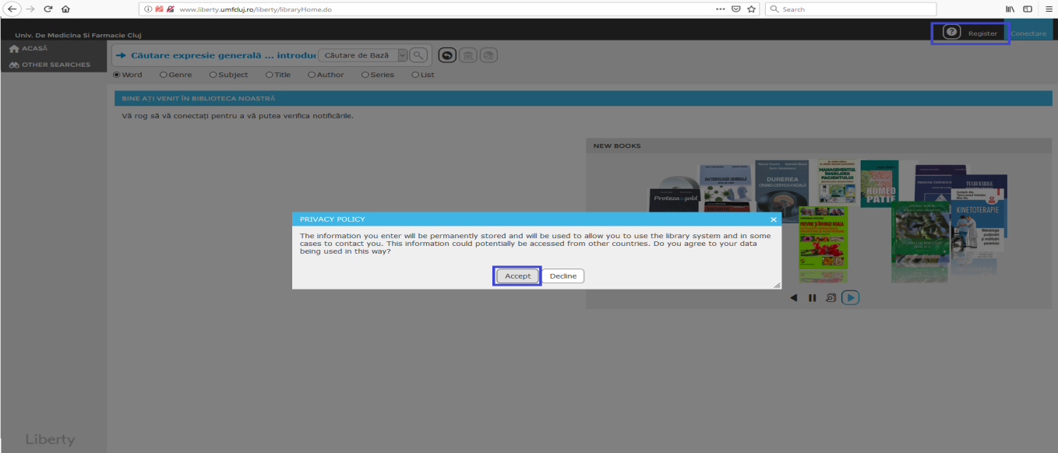

Please select **Register** and then click **Accept** to access the registration form.

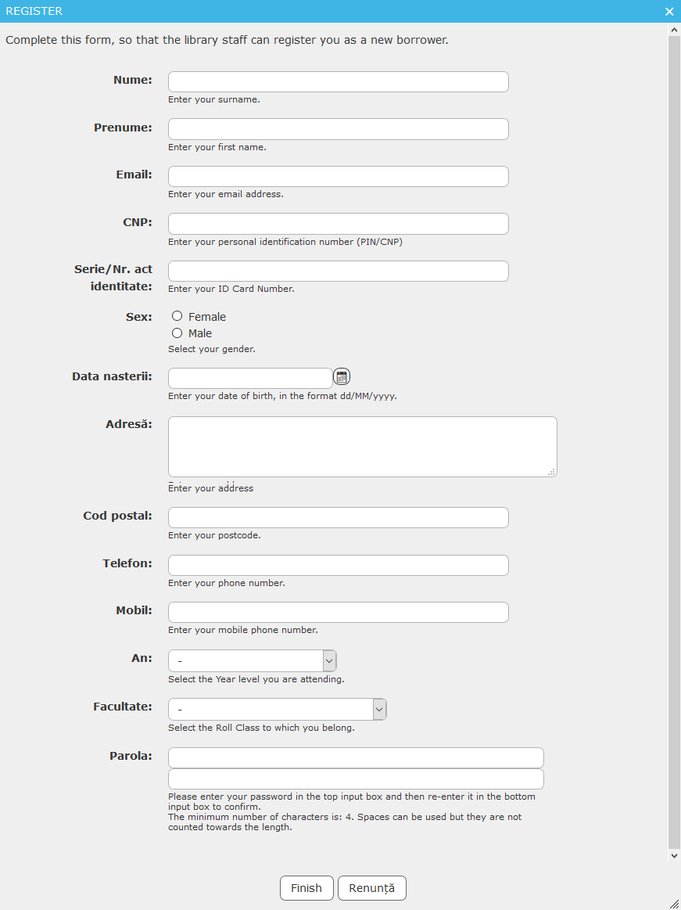

Notes:

* Name (The name must be entered in CAPITALS)
* Address (The address mentioned in your identification papers)
* Password (You are free to choose your own password and, please make sure you remember it). It is important because, when your library card is issued, you will be given a unique barcode which, together with this password, will give you access to several services of our library.

When the form is filled in, please click Finish!

Next you need to come to either of these two library locations: Victor Babeş 8 branch, 4th floor OR Haşdeu branch on B. P. Haşdeu no 33-68. Please make sure you have an identification paper (passport will do) so that our staff finishes your registration and hands your library card. The Card is unique, personal and may not be used by anyone other than the user it belongs to.